**List the first name, last name, department name and current job title of all staff. (1 mark)**

SELECT

first_name, last_name, job_title, department_name

FROM

(staff

LEFT JOIN departments ON staff.department_id = departments.department_id)

NATURAL JOIN

jobs;

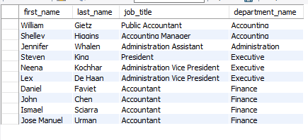

107 row(s) Returned

**List every country name and the number of staff in each country. Order the result by country name. (1 mark)**

SELECT

countries.country_name, COUNT(staff_id) AS Count

FROM

staff

NATURAL JOIN

departments

NATURAL JOIN

locations

RIGHT OUTER JOIN

countries ON locations.country_id = countries.country_id

GROUP BY countries.country_id

ORDER BY country_name

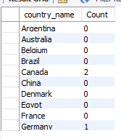

25 row(s) returned

**Who has spent the shortest amount of time in a job? Print their name (first and last name), how long the job lasted in days and the job title. (1 mark)**

SELECT

staff.first_name,

staff.last_name,

DATEDIFF(job_history.end_date,

job_history.start_date),

jobs.job_title

FROM

job_history

NATURAL JOIN

staff,

jobs

WHERE

staff.staff_id = job_history.staff_id

AND job_history.job_id = jobs.job_id



1 row(s) returned

**For all supervisors who supervise five or more staff, list their first name, last name, job title, and the number of staff members they supervise. (2 marks)**

SELECT

supervisors.first_name,

supervisors.last_name,

job_title,

COUNT(staff.staff_id) AS number_of_staff_supervised

FROM

staff supervisors

INNER JOIN

staff ON supervisors.staff_id = staff.supervisor_id

INNER JOIN

jobs ON supervisors.job_id = jobs.job_id

GROUP BY supervisors.staff_id

HAVING number_of_staff_supervised > 4;

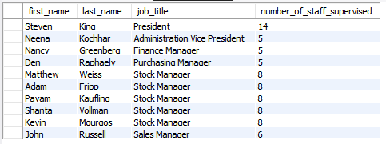

14 row(s) returned

**Print department names of departments that currently have neither a manager nor any staff. (2 marks)**

SELECT

department_name

FROM

departments

WHERE

department_id NOT IN (SELECT

departments.department_id

FROM

departments,

staff

WHERE

staff.department_id = departments.department_id)



16 row(s) returned

**Which region has the most locations? Print the region name, as well as the total number of locations in that region. (2 marks)**

SELECT

regions.region_name, COUNT(regions.region_name)

FROM

(locations

NATURAL JOIN countries),

regions

WHERE

countries.region_id = regions.region_id

GROUP BY region_name

ORDER BY COUNT(regions.region_name) DESC

LIMIT 1



1 row(s) returned

**Some staff members are eligible for a commission. Find the names of staff who will exceed the maximum salary for their job title if they achieve their commission. The calculation of a staff member’s total income if the commission is achieved is their salary multiplied by the commission percent and added onto their original salary. List the staff member’s first name, last name and the amount by which they will exceed the maximum salary for their current job role. Order the results from the highest amount to lowest. (2 marks)**

SELECT

staff.first_name,

staff.last_name,

jobs.job_title,

(staff.salary + (staff.salary * commission_pct) - max_salary) AS exceeding_salary

FROM

staff

NATURAL JOIN

jobs

WHERE

staff.job_id = jobs.job_id

AND staff.commission_pct IS NOT NULL

AND staff.salary + (staff.salary * commission_pct) > max_salary

ORDER BY exceeding_salary DESC

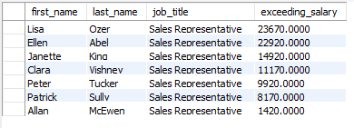

7 row(s) returned

**List the cities, country names and region names for cities outside the United States of America and Europe where no staff work. (3 marks)**

SELECT

city, country_name, region_name

FROM

locations

NATURAL JOIN

countries

NATURAL JOIN

regions

WHERE

location_id NOT IN (SELECT

location_id

FROM

staff

NATURAL JOIN

departments

NATURAL JOIN

locations)

AND country_name != 'United States of America'

AND region_name != 'Europe'

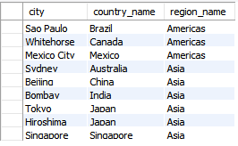

9 row(s) returned

**Print job titles, the date the jobs ended, and the current manager’s first and last name for all jobs that ended in 2006 which are currently not managed by Steven King. (3 marks)**

SELECT

job_title, end_date, first_name, last_name

FROM

job_history

NATURAL JOIN

departments,

jobs,

staff

WHERE

YEAR(end_date) = '2006'

AND manager_id != 100

AND jobs.job_id = job_history.job_id

AND manager_id = staff.staff_id

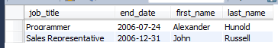

2 row(s) returned

**Print the first name, last name and current salary for all staff who held more than one job position prior to their current position, and whose current salary is below the 3 INFO20003 A2-S1-2018 average value of maximum salaries for all positions they held in the past prior to their current position. (3 marks)**

SELECT

first_name, last_name, salary

FROM

job_history,

jobs,

staff

WHERE

staff.staff_id = job_history.staff_id

AND job_history.job_id = jobs.job_id

GROUP BY job_history.staff_id

HAVING salary < AVG(max_salary)



2 row(s) returned